**Grocery Shop Management System**

**AProjectReportSubmittedto**



**RajivGandhiProudyogikiVishwavidyalaya,BhopalTowardsPartialFulfillmentfortheAwardof**

**Bachelor of Technology(ComputerScienceand Engineering)**

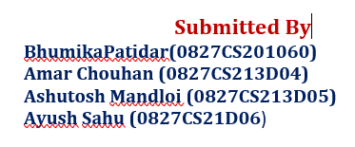



**Department of Computer Science and EngineeringAcropolisInstituteofTechnology&Research,Indore**

**July-Dec2022**

**EXAMINERAPPROVAL**

TheProjectentitled“**Grocery Shop Management System**”submittedbyBhumika Patidar(0827CS201060), Amar Chouhan(0827CS213DO4),Ashutosh Mandloi (0827CS213D05) andAyushSahu (0827CS213D06) has been examined and is hereby approved towardspartial fulfillment for the award of Bachelor of Engineering degree in Computer Science &amp;Engineering discipline, for which it has been submitted. It understood that by this approval theundersigned do not necessarily endorse or approve any statement made, opinion expressed orconclusion drawn therein, but approve the project only for the purpose for which it has beensubmitted.

**(InternalExaminer) (ExternalExaminer)**

**Date: Date:**

**GUIDERECOMMENDATION**

This is to certify that the work embodied in this project entitled “**Grocery Shop Management System** ”submitted byBhumika Patidar(0827CS201060), Amar Chouhan(0827CS213DO4),Ashutosh Mandloi (0827CS213D05) andAyushSahu (0827CS213D06) is a satisfactory account ofthe bonafide work done under the supervision of Prof. Ronak Jain towards partial fulfillment for the award of the Bachelor of Engineering(ComputerScience&Engineering)degree by Rajiv Gandhi ProudyogikiVishwavidhyalaya,Bhopal.

**(ProjectGuide) (ProjectCoordinator)**

**STUDENTSUNDERTAKING**

This is to certify that a project entitled “Smart Accessibility Map” has developed by us under thesupervisionofProf.Ronak Jain Thewholeresponsibility of work done in this project is ours. The sole intention of this work is only forpractical learning and research. We further declare that to the best of our knowledge, this reportdoes not contain any part of any work which has been submitted for the award of any degreeeither in this University or in any other University / Deemed University without proper citationand if the same work is found then we are liable for explanation to this.

**BhumikaPatidar(0827CS201060)**

**Amar Chouhan (0827CS213D04)**

**Ashutosh Mandloi (0827CS213D05)**

**AyushSahu (0827CS21D06**)

**Acknowledgement**

We thank the almighty Lord for giving me the strength and courage to sail out through the toughand reach on shore safely. There are a number of people without whom this project's work wouldnot have been feasible. Their high academic standards and personal integrity provided me withcontinuous guidance and support. We owe a debt of sincere gratitude, deep sense of reverenceand respect to our guide and mentors **Prof. Ronak Jain**,AssociateProfessor,AITR,fortheirmotivation,sagaciousguidance,constantencouragement, vigilant supervision and valuable critical appreciation throughout this projectwork,whichhelpedustosuccessfullycompletetheprojectontime. We express profoundgratitudeandheartfeltthankstoDrKamalKumarSethi,HODCSE,AITRIndorefor hissupport, suggestion and inspiration for carrying out this project. I am very much thankful to otherfaculty and staff members of CSE Dept, AITR Indore for providing me all support, help andadvice during the project. We would be failing in our duty if we do not acknowledge the supportand guidance received from Dr S C Sharma, Director, AITR, Indore whenever needed. We taketheopportunitytoconveymyregards to the management of Acropolis Institute, Indore forextending academic and administrative support and providing me with all necessary facilities forthe project to achieve our objectives. We are grateful to our parents and family members whohave always loved and supported us unconditionally. To all of them, we want to say, “Thankyou”, for being the best family that one could ever have and without whom none of this wouldhave been possible.

**BhumikaPatidar(0827CS201060)**

**Amar Chouhan (0827CS213D04)**

**Ashutosh Mandloi (0827CS213D05)**

**AyushSahu (0827CS21D06**)

**ExecutiveSummary**

This project is submitted to Rajiv Gandhi Proudyogiki Vishwavidhyalaya, Bhopal(MP), India for partial fulfillment of Bachelor of Engineering in Computer Science&Engineering branchunderthesagaciousguidanceandvigilantsupervisionofProf.Ronak Jain,The project is awebsite. In the project, we examinesorprovidesatheoreticalperspectiveon“GROCERYSHOPMANAGEMENT SYSTEM” that is used to automate all process of the Grocery Shopping and GroceryShop Management. The purpose of Grocery Shop Management System is to automate the existingmanual system by the help of computerized equipments and full-fledged computer software, fulfillingtheirrequirements, so that their valuable data/information can be stored for a longer period witheasyaccessingandmanipulationofthesame.

***“****People are always going to go shopping. A lot of our effort is just ‘how do we make the retail experience a great one?*

***— Phillip Green, Chairman, Arcadia Group***

|  |  |  |  |
| --- | --- | --- | --- |
|  | | ***Tableofcontents*** | |
| **Chapter 1. Introduction** | |  | |
| ……………………………………………… | |
| 1.1 Overview | |
| ……………………………………………… | |
| 1.2 Background and Motivation | |
| ……………………………………………… | |
| 1.3 Problem Statement and Objectives | |
| ……………………………………………… | |
| 1.4 Scope of the Project  ……………………………………………… | |
| 1.5 Group Organization  ……………………………………………… | |
| 1.6 Report Structure  ……………………………………………… | |
| **Chapter 2. Review of Literature**  ……………………………………………… |
| 2.1 Preliminary Investigation  ……………………………………………… | | | **15** |
| 2.1.1 Current System and its Limitations  ………………………………………………. | | | **15** |
| 2.2 Limitation of Current System | | |  |
| ………………………………………………  2.3 Conclusion  ……………………………………………… | | | **19** |
|  | | | **20** |
|  | | | **21** |
|  | | | **22** |
| **Chapter 3 . Proposed System**  ………………………………………………  3.1 The Proposal  ……………………………………………… | | | **22** |
| 3.2 Benefits of Proposed System  ………………………………………………  3.3 Block Diagram  ………………………………………………  3.4 Design Representations  ………………………………………………  3.5 Diagrams  **Chapter 4 . Implementation**  ……………………………………………… **29**   * 1. Technology Used   ……………………………………………… **29**   * 1. Testing / Test Cases   ……………………………………………… 4.2.1 Login  ………………………………………………  4.2.2 Employee record  ………………………………………………  4.2.3 Category record  ………………………………………………  4.2.4 Customer record  **Chapter 5 . Conclusion**  ………………………………………………   * 1. Limitations   ………………………………………………   * 1. Suggestions and Recommendations   ………………………………………………      **____** | | | **22** |
|  | | |  |

**Chapter 1 . Introduction**

Introduction

# The Grocery Shop Management System has been developed to override the problems prevalling in the practicing manual system. This software is supported to eliminate and in some cases reduce the hardships faced by this existing system.The application is reduced as much as possible to avoid errors while entering the data. It also provides error message while entering invalid data. No format knowledge is needed for the user to use this system. Thus by this all it proves It is user-friendly. Grocery Shop Management System , as described above, can lead to error free, secure, reliable and fast management system.

# Overwiew

# Every organization, whether big or small, has challenges to overcome and managing the information of the product , customer, product type, stock, supplier. Every Grocery Shop Management System has different customer needs, therefore we design exclusive employee management system that are adapted to your managerial requirements. This is designed to assist in strategic planning, and will help you ensure that your organization is equipped with the right level o information and details for your future goals. These systems will ultimately allow you to better manage resources.

# Background and motivation

* 1. **Problem satatement and objectives**

Grocery shopping these days has become a job. The client needs to continuously monitor groceries at home and also has the work of directing coupons, maintaining shopping lists, standing in restraint out queues, reading the fine print on food cans, and even needs to find out within which rack and row he or she may notice that object. A large amount of the grocery shoppers would thus have an interest in an additional appropriate, rapidly grocery shopping option. Presently life for everyone has become so confused and time consuming, at such time we require a smart system at our kitchen also.

The main objective of the project in Grocery Shop Management System is to manage the details of Customer, Product, product company, product type, supplier. It manages all the information about customer , Stock, Supplier, Customer. The project is totally built at administrative end and thus only the administrator is guranted the access. The purpose is to build an application program to reduce the manual work for managing the customer, product, stock, product company. It tracks all details about the product company, product type, supplier.

* 1. **Scope of the Project**

It may help collecting perfect management in details. In a very short time, the collection will be obvious, simple and sensible. It will help a person to know the management of passed year perfectly and vividly. It also helps in current all works relative to Grocery Shop Management System. It will be also reduced the cost of collecting the management & collection procedure will go on smoothly. Our project aims at Business process automation, we have tried to computerize various processes of Grocery Shop Management System. In computer system the person has to fill the various forms & number of copies of the forms can be easily generated at a time. In computer system, it is not necessary to create the manifest but we can directly print it, which saves our time. To assist the staff in capturing the effort spent on their respective working areas. To utilize resources in an efficient manner by increasing their productivity through automation .The system generates types of information that can be used for various purposes.

* It satisfy the user requirement.
* Be easy to understand by the user and operator.
* Be easy to operate Have a good user interface
* Be expandable
* Delivered on schedule within the budget.
  1. **Group Organization**
     1. **Bhumika patidar**

Along with doing preliminary investigation and understanding the drawback of the current system I studied about the topic and its scope and surveyed various research papers related to object detection and the technology that is to be used. I worked on the front end along with I worked on databases by making tables in it and connecting it to projects. Also I helped in debugging the code and made the login and register pages with validation.

**Amar chouhan**

I investigated and found the right technology and studied deep about it. I decided which framework should be suitable for this project . I also worked on database part making and storing results in it also connecting it to the project. I also organized and debug the code of the project.Implementation logic for the project objective and coding of internal functionalities is also done by me. I worked on documentation.

* + 1. **Ashutosh Mandloi**

I made the html templates i worked on CSS of the project. I worked on documentation.

**Ayush sahu**

I also made some of the html templates and implemented css in it.

* 1. **Report Structure**

Chapter 1: Introduction- introduces the background of the problem followed by rationale for the project undertaken. The chapter describes the objectives, scope and applications of the project. Further, the chapter gives the details of team members and their contribution in development of project which is then subsequently ended with a report outline.

Chapter 2: Review of Literature- explores the work done in the area of Project undertaken and discusses the limitations of existing system and highlights the issues and challenges of project area. The chapter finally ends up with the requirement identification for present project work based on findings drawn from reviewed literature and end user interactions.

Chapter 3: Proposed System - starts with the project proposal based on requirement identified, followed by benefits of the project. The chapter also illustrate software engineering paradigm used along with different design representation. The chapter also includes block diagram and details of major modules of the project. Chapter also gives insights of different type of feasibility study carried out for the project undertaken. Later it gives details of the different deployment requirements for the developed project.

Chapter 4: Implementation - includes the details of different Technology/ Techniques/ Tools/ Programming Languages used in developing the Project. The chapter also includes the different user interface designed in project along with their functionality. Further it discuss the experiment results along with testing of the project. The chapter ends with evaluation of project on different parameters like accuracy and efficiency.

Chapter 5: Conclusion - Concludes with objective wise analysis of results and limitation of present work which is then followed by suggestions and recommendations for further improvement.

**Chapter 2 . Review of Literature**

Review of Literature

* 1. **Preliminary Investigation**

The first step in the system development life cycle is the preliminary investigation to determine the feasibility of the system. The purpose of the preliminary Investigation is to evaluate project requests. It is not a design study nor does it include the collection of details to describe the business system in all respect. Rather, it is the collecting of information that helps committee members to evaluate the merits of the project request and make an informed judgment about the feasibility of the proposed project.

Analysts working on the preliminary investigation should accomplish the following objectives:

⚫ Clarify and understand the project request

• Determine the size of the project

• Assess costs and benefits of alternative approaches.

• Determine the technical and operational feasibility of alterative approaches, ⚫ Report the findings to management, with recommendations outlining the acceptance or rejection of the proposal, Benefit to Organization The organization will obviously be able to gain benefits such as savings in operating cost, reduction in paperwork, better utilization of human resources and more presentable image increasing goodwill.

The Initial Cost

The initial cost of setting up the system will include the cost of hardware software (OS, add-on software, utilities) & labour (setup & maintenance). The same has to bear by the organization.

**2.1.1Current System and its Limitations**

Grocery shopping these days has become a job. The client needs to continuously monitor groceries at home and also has the work of directing coupons, maintaining shopping lists, standing in restraint out queues, reading the fine print on food cans, and even needs to find out within which rack and row he or she may notice that object. A large amount of the grocery shoppers would thus have an interest in an additional appropriate, rapidly grocery shopping option. Presently life for everyone has become so confused and time consuming, at such time we require a smart system at our kitchen also.

**Merits :-**

The provision of sorting or prioritizing search results allows users to better meet their own needs by allowing users to have more control over the online grocery store.

**Demerits :-**

In the case where a user chooses to browse the site (Linking) rather than employ the search facility, it is essential to provide

meaningful labels and menu names to aid navigation (Freeman, 2009). Bannister (2002) suggests that strong and relevant cross selling serves as extra navigation for users who wish to browse rather than having a set list, as well as increasing

product sales by ‘suggesting’ associated products

**2 .2. LIMITATION OF CURRENT SYSTEM**

|  |  |  |  |  |  |
| --- | --- | --- | --- | --- | --- |
| Name | Description | Merits | Demerits | | Reference |
| **Online grocery manage-ment system**  **Modern Grocery mart project** | Grocery shopping these days has become a job. The client needs to continuously monitor groceries at home and also has the work of directing coupons, maintaining shopping lists, standing in  restraint out queues, reading the fine print on food cans, and even needs to find out within which rack and row he or she may notice that object. A large  amount of the grocery shoppers would thus have an interest in an additional appropriate, rapidly grocery shopping option. Presently life for everyone has  become so confused and time consuming, at such  time we require a smart system at our kitchen also.  Grocery business is the only business that one can start almost anywhere since food is essential for survival of human beings and selling food items is the most profitable business of all time. Grocery shopping is the largest and most consistent share of the expenses for every household. Groceries sell irrespective of the state of the economy. The recent corona-virus outbreak has led to lockdowns world-wide and many businesses suffered due to this pandemic | The provision of sorting or  prioritizing search results allows users to better meet  their own needs by allowing users to have more  control over the online grocery store.  .  A Project Report is notonly essential for obtaining financial assistance from Bank/ Financial Institution/Funding Agency but also the most important document either to participate in the development schemes of MSME Sector/ Department of Industries or in completing various time consuming government formalities connected with planning and commercial operation of the proposed business project. | | In the case  where a user chooses to browse the site (Linking) rather than employ the search facility, it is essential to  provide  meaningful labels and menu names to aid navigation (Freeman, 2009). Bannister (2002)  suggests that strong andrelevant cross selling serves  as extra navigation for users who wish to browse  rather than having a set list, as well as increasing  product sales by ‘suggesting’ associated products.  . Accordingly, following Project Templates has been deliberately left blank in order to facilitate customisation by the perspective entrepreneurs based on personal requirements and furnish necessary information on actual basis. | [(PDF) ONLINE GROCERY MANAGEMENT SYSTEM (researchgate.net)](https://www.researchgate.net/publication/352477571_ONLINE_GROCERY_MANAGEMENT_SYSTEM)  https://www.onlineprojectreport.com/modern-grocery-mart-project-report/p1064192/ |
| **Retail Business PlanOn General Store** | The main objective of this project is to give hands onexperience of creating a detailed Business plan &what are thethings include while making a business Plan. It is my pleasure to present this project work.This Project has expanded my horizon of knowledge in practicalas well as theoretical, which is vital for management levelstudents. Only the basic understanding of the principles ofmanagement is not sufficient but their application is also equallyimportant | Become an established community destination with a customer satisfaction rate of 90% by the end of the nextfinancial year. Achieving Sales Turnover of Rs.4, 00,000Per month innext year. Hiring 5 five new employees for the Store. Repay debt from original financing by the end of the nextthree years. | It organized segment typically comprises of a large numberof retailers, greater enforcement of taxation mechanisms and betterlabour law monitoring system. | | https://www.academia.edu/37856787/A_project_Report_on_Retail_Business_Plan_On_General_Store |
| **CROLIST** | The common practice of generating a grocery list is by writing the items to be bought on a piece of paper. Although the method has been used for ages; nevertheless, a paper grocery list could be easily contaminated by liquids and dirt, difficult in reading handwriting, and may be left at home or even misplaced. The development in smartphones and mobile technology has been a solution to overcome the limitations in paper-based grocery lists where mobile apps can support the process of creating and managing grocery lists more conveniently and flexibly | The digital grocery lists are created instantly and stored in individual users’ smartphones, in which they can be easily retrieved back for updating the items or as a reference during the grocery shopping process. Although the digital grocery lists align with the current human lifestyle and technological trend, they are unable to support a collaborative environment. | The current mobile apps for creating digital grocery lists do not provide the facility to share a grocery list among household members. The lists are not able to be updated instantly by other household members who generally consume grocery products in the house and wish to assist in creating a grocery list. It is the main limitation of the existing mobile apps CROLIST: A Mobile App for Collaborative Grocery List Management for creating and maintaining grocery lists in which it is unable to support household members’ needs in managing a shared grocery list together using their own smartphones. | | https://www.warse.org/IJATCSE/static/pdf/file/ijatcse55852019.pdf |
| **Big bazar** | Retail means selling goods and services in small quantities directly to the customer. Retailingconsists all activities involved in marketing of goods and services directly to the consumers fortheir personnel family and household use.The Indian retail market is the first position on theretail destination globally, has been ranked as the most attractive emerging market forinvesting in the retail sector by AT Kearney ninth annual global retail developmentindex(GRDI) in 2010. With rising consumer demand and greater disposable income, the US$400 billion Indian retail sector is clocking an annual growth rate 30 percent. | The organised retailsector, which currently accounts for around 7.5 per cent of the Indian retail market, is all set towitness maximum number of large format malls and branded retail stores in south India, ollowed by North, West and the East in the next to years. Tier ІІ cities like Noida, Amritsar,kochi, and Gurgaon, are emerging as the favored destination for the retail sector worth theirhuge growth potential Further, this sector is expected to invest around US$ 503.2 million inretail technology service solutions in the current financial yea. This could go further up to US$1.26 billion in the next year , at the CARG of 40 per cent. | .Unable to meet store opening targets on time.  Falling revenue per sq ft.  General perception: 'Low price = Low quality'  Overcrowded during offers.  Long lines at billing counters which are time consuming.  Limited only to value offering low price products. | | <https://www.academia.edu/7815738/Sunil_big_bazar_project_report> |
| **Grocery**  **Shopping android**  **project** | You want to buy grocery but you don’t have sufficient options, then you can download this application. Here, you will get a large variety of groceries available in the market along with different ranges and material. You can purchase number of groceries from here, and can pay online too via credit card. | You can order grocery online using this system application for android operating system and also pay via credit card or online banking as well. This Grocery Shopping Android system will save time and efforts while buying groceries. | Disadvantages included inadequate substitutions, the online shopping fee, lack of control over selection of perishable goods, and inability to find good deals online versus in the store | | <https://projectsgeek.com/2016/05/grocery-shopping-android-project.html> |

* 1. **Conclusion**

This chapter reviews the literature surveys that have been done during the research work. The related work that has been proposed by many researchers has been discussed. After surveying the existing systems, finding out the advantages and disadvantages .

**Chapter 3 . Proposed System**

Proposed System

**3.1 The Proposal**

The proposal is to automate its existing manual system by the help of computerized equipments and full-fledged computer software , fulfilling their requirements, so that their valuable data/information can be stored for a longer period with easy accessing and manipulation of the same. Basically the project describes how to manage for good performance and better services for the clients.

**3.2 Benefits of Proposed System**

The aim of proposed system is to develop a system of improved facilities. The proposed system can overcome all the limitations of the existing system. The system provides proper security and reduces the manual work.

• Security of data.

* Ensure data accuracy's.
  + - * Proper control of the higher officials.
* Minimize manual data entry.
* Minimum time needed for the various processing.
* Greater efficiency.
* Better service.
  + - * User friendliness and interactive.
      * Minimum time required

**3.3 Diagrams-**

**DIAGRAMS:-**

**Level1**

Userdetails

User

Loginn

Details

Newuser

Register

**Level0**

**Userdetails Details**

**DataBase**

**User**

**Report Report**

Level1

Login

Usernamepassword

Feedback

Newinfo

userinfo

Changeinfo

Admin

Createuser

account

Feedback

Feedback

Newpricecost

Changeitems

Addnewitems

**Employee**

**Level0**

**Employee details Details**

**DataBase**

**Employee**

GMS

**Report Report**

**Admin**

**Userdetails Details**

**DataBase**

**Admin**

GMS

**Report Report**

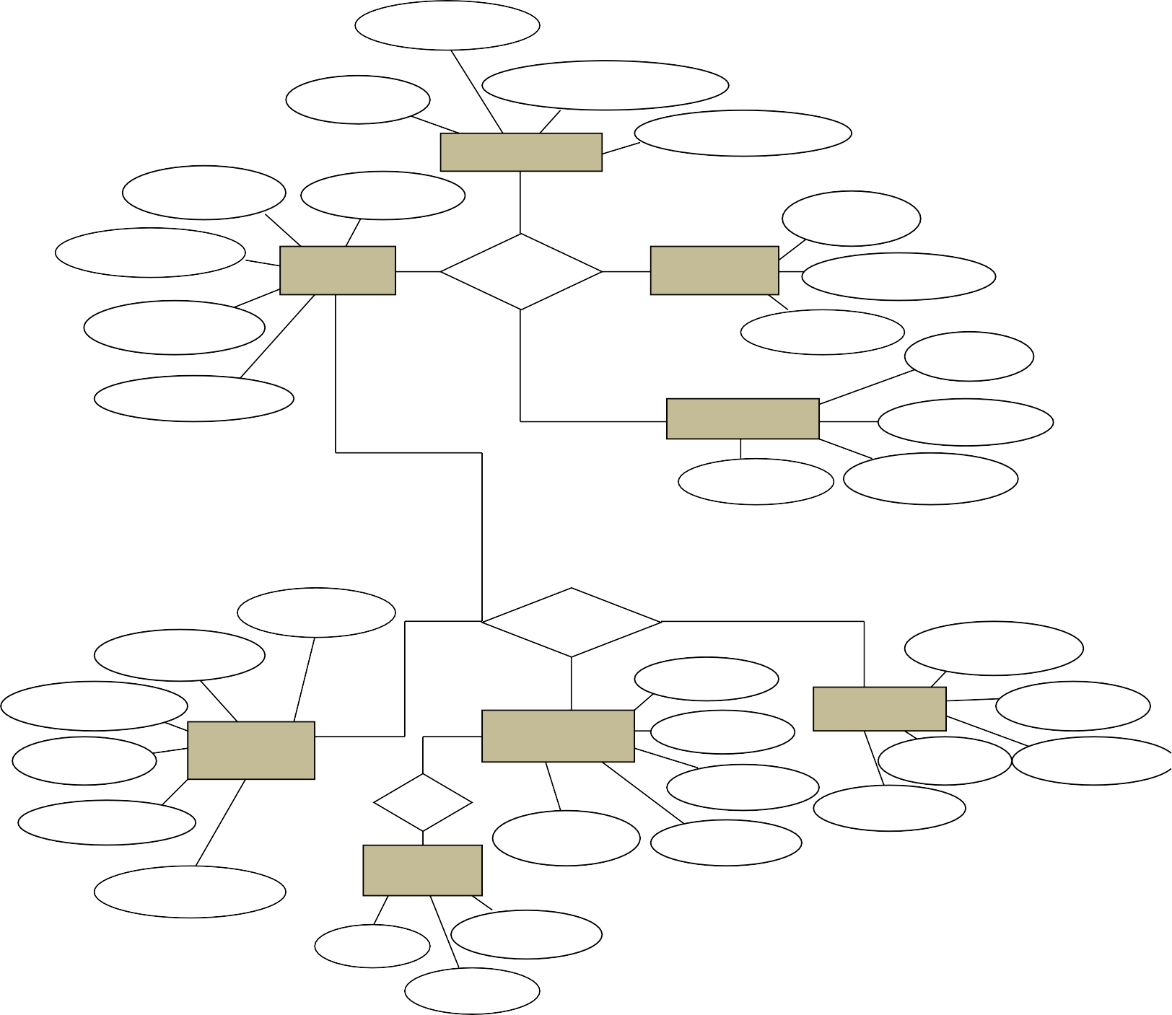

**Admin**

#loginid

loginroleid

LoginusernameLogin

Userpassword

User nameUsermobile

Useremail

#pernameUser

Has Roles

#roleid

Role nameRoledesc

#perid

Useraddress

Permissions

Perroleid

Pername

Permodule

Procusid

Userid

Pronum

Manage

Billdesc

Customer

Cusmobile

#cusid

ProdescProiteams

Protype

Product Bill

Has

#billid

Stock

BilldateBillcusid

Billnum

Cus addCuspass

Cusname

#stkid

Stkdesc

Stktype

ERDiagramForStoreManagementSystem

* 1. **Design Representations**

Front End

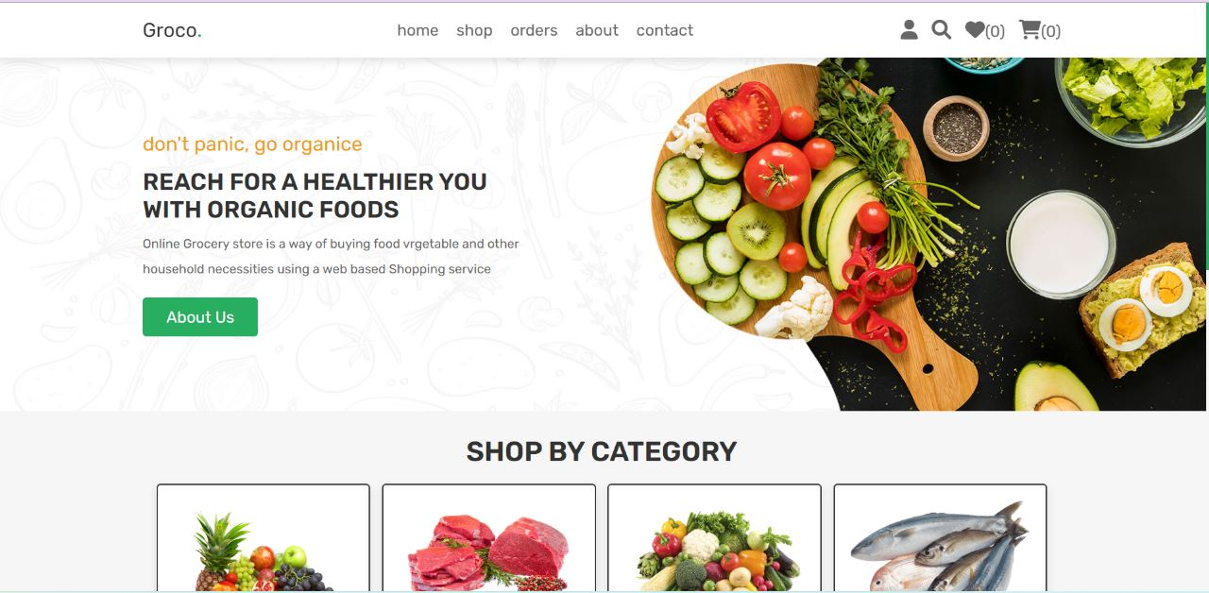

Fig.1

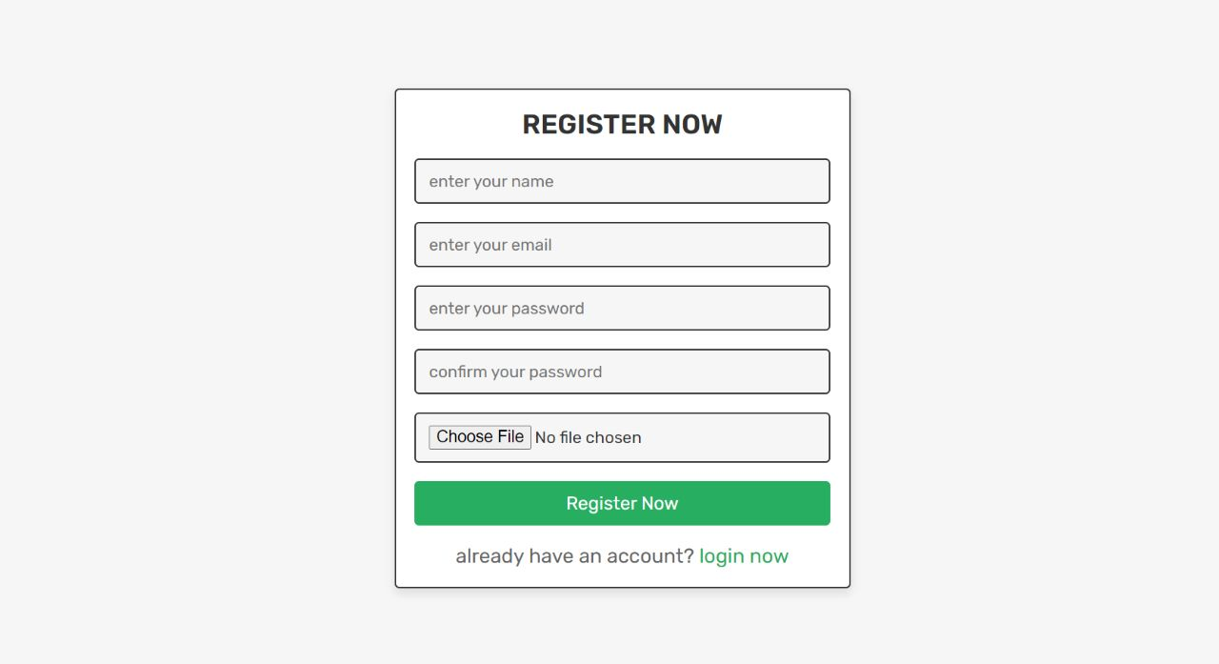

Fig.2

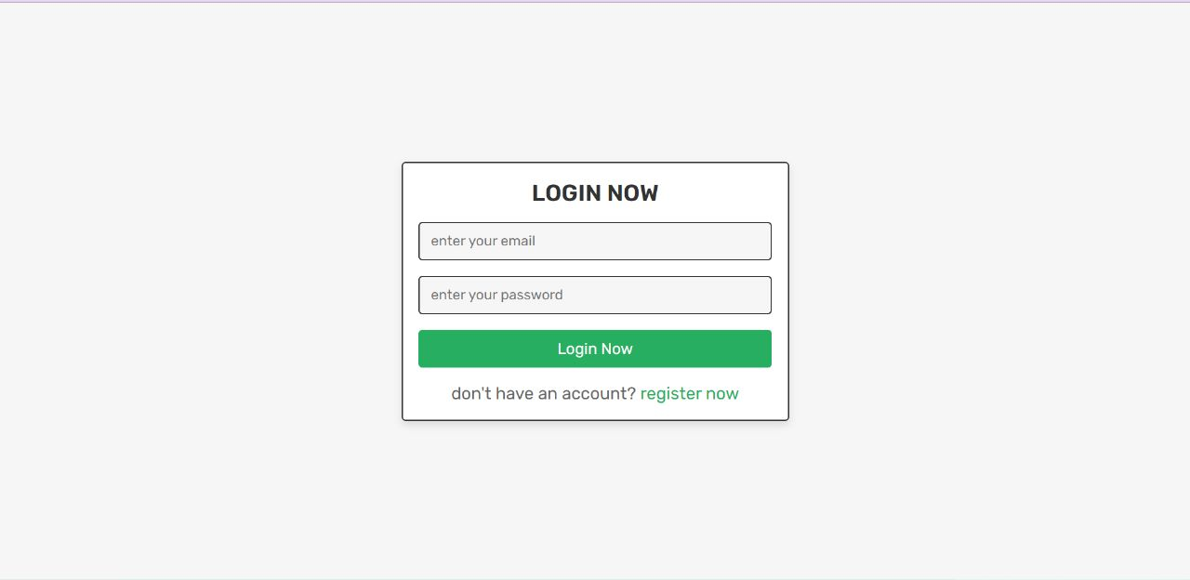

Fig.3

* 1. **Deployement Requirements**

**3.5.1. Hardware**

|  |  |
| --- | --- |
| **Name of component** | **Specification** |
| **Processor** | **Intel core** |
| **RAM** | **128** |
| **Hard disk** | **20 GB** |
| **Monitor** | **20” color monitor** |
| **Keyboard** | **122 Keys** |

**3.5.2. Software**

Front end: HTML, CSS, JavaScript

HTML: HTML is used to create and save web document. E.g. Notepad/Notepad++

CSS : (Cascading Style Sheets) Create attractive Layout

Bootstrap : responsive design mobile freindly site.

JavaScript: it is a programming language, commonly use with web browsers.

Back end: PHP, MySQL

PHP(version - 7.2): Hypertext Preprocessor (PHP) is a technology that allows software developers to create dynamically generated web pages, in HTML, XML, or other document types, as per client request. PHP is open source software.

MySQL: MySql is a database, widely used for accessing querying, updating, and managing data in databases.

**Chapter 4 . Implementation**

Implementation

**4.1 Technique Used**

Model View Controller or MVC as it is popularly called, is a software design pattern for developing web applications. A Model View Controller pattern is made up of the following three parts: ⚫ Model - The lowest level of the pattern which is responsible for maintaining data.

⚫ View - This is responsible for displaying all or a portion of the data to the user. • Controller - Software Code that controls the interactions between the Model and View.

MVC is popular as it isolates the application logic from the user interface layer and supports separation of concerns. Here the Controller receives all requests for the application and then works with the Model to prepare any data needed by the View. The View then uses the data prepared by the Controller to generate a final presentable response. The MVC abstraction can be graphically represented as follows. MVC (Model View Controller Flow) Diagram.

**4.2 Testing**

**4.2.1**

**Login :-**

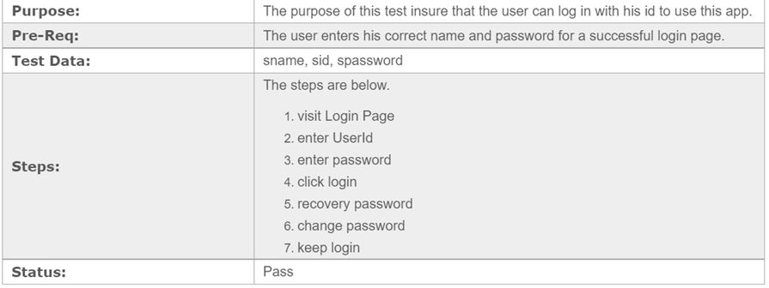

**4.2.2**

**Employee record**

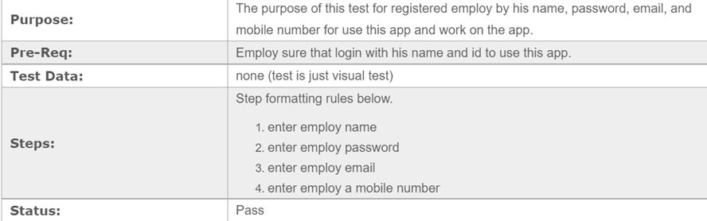

**4.2.3**

**Category record**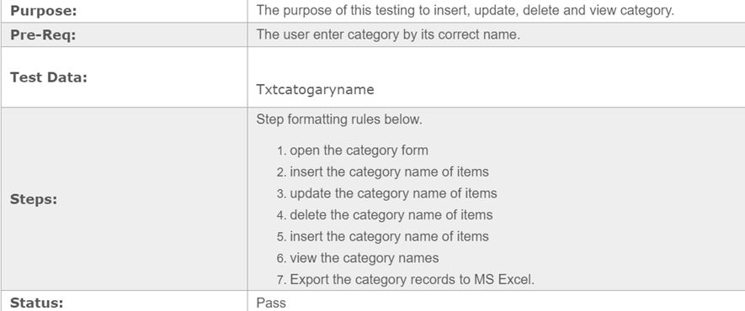

**4.2.4 Customer record**

**Security Testing of the Project**

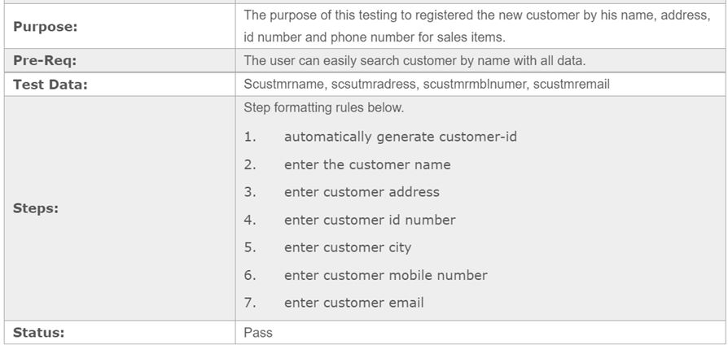

Testing is vital for the success of any software, no system design is ever perfect. Testing is also carried in two phases, first phase is during the software engineering that is during the module creation. second phase is after the completion of software, this is system testing which verifies that the whole set of programs hanged together.

White Box Testing:

In this technique, the close examination of the logical parts through the software are tested by cases that exercise species sets of conditions or loops. all logical parts of the software checked once errors that can be corrected using this technique are typographical errors, logical expressions which should be executed once may be getting executed more than once and error resulting by using wrong controls and loops. When the box testing tests all the independent part within a module a logical decisions on their true and the false side are exercised, all loops and bounds within their operational bounds were exercised and intemal data structure to ensure their validity were exercised once

Black Box Testing:

This method enables the software engineer to device sets of input techniques that fully exercise all functional requirements for a program, black box testing tests the input, the output and the extemal data. it checks whether the input data is correct and whether we are getting the desired output

Alpha Testing:

Acceptance testing is also sometimes called alpha testing. Be spoke systems are developed for a single customer. The alpha testing proceeds until the system developer and the customer agree that the provided system is an acceptable implementation of the system requirements.

Beta Testing:

On the other hand, when a system is to be marked as a software product, another process called beta testing is often conducted During beta testing, a system is delivered among a number of potential users who agree to use it. The customers then report problems to the developers. This provides the product for real use and detects errors which may not have been anticipated by the system developers:

Unit Testing:

Each module is considered independently, it focuses on each unit of software as implemented in the source code. it is white box testing

Integration Testing:

Integration testing aims at constructing the program structure while at the same constructing tests to uncover errors associated with interfacing the modules modules are integrated by using the top down approach

Validation Testing:

Validation testing was performed to ensure that all the functional and performance requirements are met.

System Testing:

It is executing programs to check logical changes made in it with intention of finding errors a system is tested for online response, volume of transaction, recovery from failure etc. System testing is done to ensure that the system satisfies all the user requirements.

**Chapter 5.Conclusion**

Conclusion

Conclusion of the Project Grocery Shop Management System**:**

Our project is only a humble venture to satisfy the needs to manage their project work. Several user friendly coding have also adopted. This package shall prove to be a powerful package in satisfying all the requirements of the school. The objective of software planning is to provide a frame work that enables the manger to make reasonable estimates made within a limited time frame at the beginning of the software project and should be updated regularly as the project progresses.

At the end it is concluded that we have made effort on following points...

• A description of the background and context of the project and its relation to work already done in the area.

• Made statement of the aims and objectives of the project.

• The description of Purpose, Scope, and applicability. ⚫ We define the problem on which we are working in the project.

• We describe the requirement Specifications of the system and the actions that can be done on these things.

• We understand the problem domain and produce a model of the system, which

describes operations that can be performed on the system.

⚫ We included features and operations in detail, including screen layouts. • We designed user interface and security issues related to system.

⚫ Finally the system is implemented and tested according to test cases.

**5.1. Limitation of Project on Grocery Shop Management System**

Although I have put my best efforts to make the software flexible, easy to operate but limitations cannot be ruled out even by me. Though the software presents a broad range of options to its users some intricate options could not be covered into it; partly because of logistic and partly due to lack of sophistication. Paucity of time was also major constraint, thus it was not possible to make the software foolproof and dynamic Lack of time also compelled me to ignore some part such as storing result of the candidate etc.

Considerable efforts have made the software easy to operate even for the people not related to the field of computers but it is acknowledged that a layman may find it a bit problematic at the first instance. The user is provided help at each step for his convenience in working with the software.

**5.2 Suggestions and Recommendations for future work**

* The website interface would be more vibrant.
* Should be more informative.